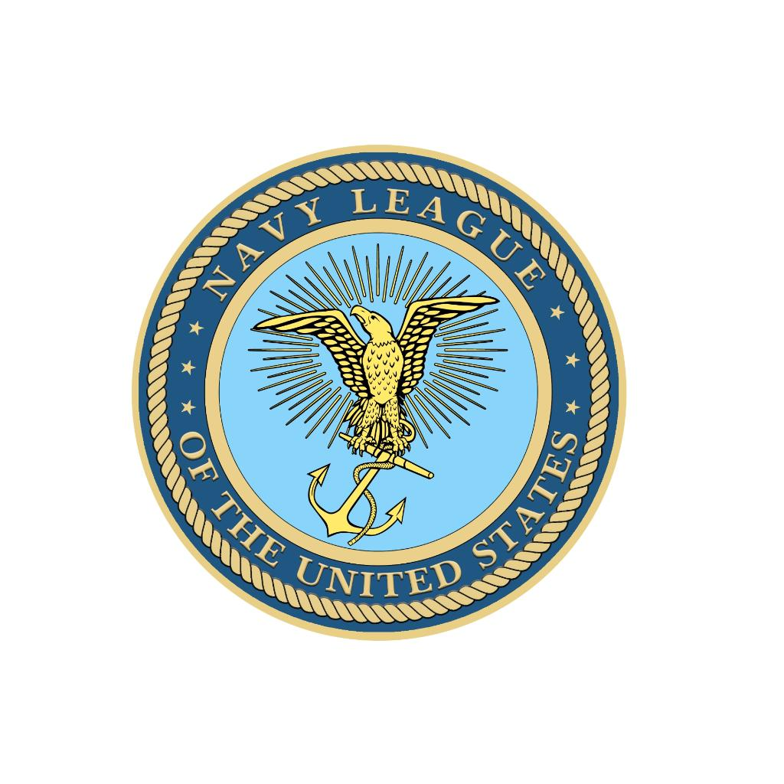 | NAVY LEAGUE CHANNEL ISLANDS COUNCIL  Citizens in Support of the Sea Services



Holiday Luncheon & Wine Auction

Sunday, December 13, 2026 · 11:30 AM – 2:30 PM · $50.00 Per Person

at Pacific Corinthian Yacht Club
2600 South Harbor Boulevard, Oxnard

Salad, Main Course, Coffee, Tea & Dessert · No Host Bar

Bring your family and friends for a fun-filled afternoon!

Credit Cards Accepted · Bring Cash for Door Prizes

For more information: Annette Block · 818-300-5840 · NetskieB@gmail.com

RSVP — Reservations Mandatory by December 1, 2026 | Checks payable to: NAVY LEAGUE CHANNEL ISLANDS

NAME __________________________________________________________________ | PERSONS ATTENDING ________

PHONE ________________________________________________ | EMAIL ____________________________________________________________

I/WE CANNOT ATTEND BUT WISH TO DONATE: $___________________

CREDIT CARD # ___________________________________________________ | EXP ____________ | CVV ___________ | ZIP _____________

* $3.00/person surcharge on credit card reservations; cards charged after 12/1/26. Text or email: 818-300-5840 / NetskieB@gmail.com

ENTRÉE SELECTION — Please indicate number of each:

Grilled Salmon, Mango Papaya Salsa, Rice Pilaf & Seasonal Vegetables | _______
Roasted Tri-Tip, Cognac Green Peppercorn Sauce, Mashed Potatoes & Seasonal Vegetables | _______
Cheese and Spinach Stuffed Ravioli with Pumpkin Sauce | _______

Mail to: Annette Block · c/o Navy League · P.O. Box 873 · Port Hueneme, CA 93044 · navyleaguecica.org

